m1=imread('img.jpeg');

m2=imresize(m1,[180,180]);

subplot(2,2,1);

imshow(m2);

title('original');

m3 =rgb2gray(m2);

subplot(2,2,2);

imshow(m3);

title('gray image');

n1=imnoise(m3,'gaussian');

subplot(2,2,3);

imshow(n1);

title("gaussain noise");

n2=medfilt2(n1);

subplot(2,2,4);

imshowpair(n1,n2,'montage');

title("filter img and noise img");

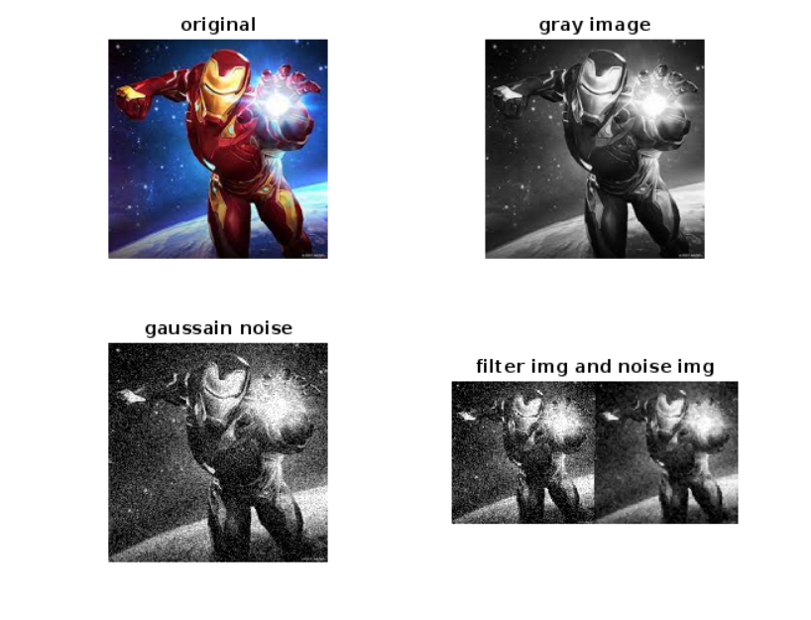

figure(2);

n3=imnoise(m3,'gaussian',0.3);

subplot(2,2,1);

imshow(n3);

title('gaussian noise with parameter');

n5 =medfilt2(n3);

subplot(2,2,2);

imshowpair(n3,n5, 'montage');

title('filter and noise');

n8=imnoise(m3,'poisson');

subplot(2,2,3);

imshow(18);

title('poisson noise');

n9 =medfilt2(n8);

subplot(2,2,4);

imshowpair(n8,19,'montage');

title("filter and noise img");

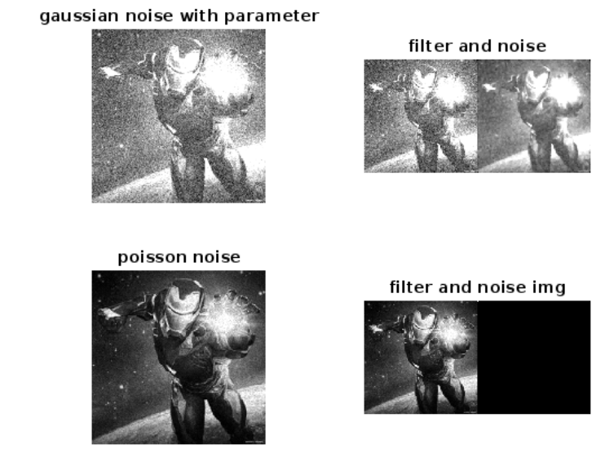

figure(3);

n6=imnoise(m3,'salt & pepper');

subplot(2,2,1);

imshow(n6);

title("salt and pepper img");

n7=medfilt2(n6);

subplot(2,2,2);

imshowpair(n6,n7,'montage');

title('filter and noise img');

n10=imnoise(m3, 'salt & pepper',0.3);

subplot(2,2,3);

imshow(n10);

title('salt and pepper with parameter');

n11=medfilt2(n10);

subplot(2,2,4);

imshowpair(n10,n11,'montage');

title('filter and noise img');

